**EXPERIMENT-13**

**Write PL/SQL program to implement Stored Procedure on table.**

**AIM:** Write PL/SQL program to implement Stored Procedure on table.

**PL/SQL Procedure**

The PL/SQL stored procedure or simply a procedure is a PL/SQL block which performs one or more specific tasks. It is just like procedures in other programming languages.

The procedure contains a header and a body.

**EXAMPLE :**

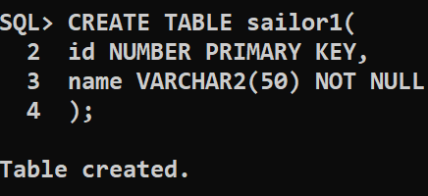

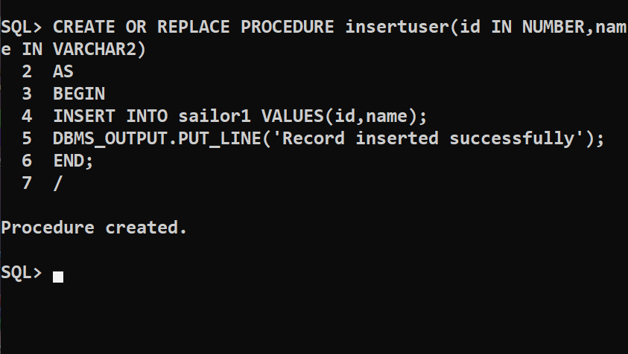

**Execution Procedure: 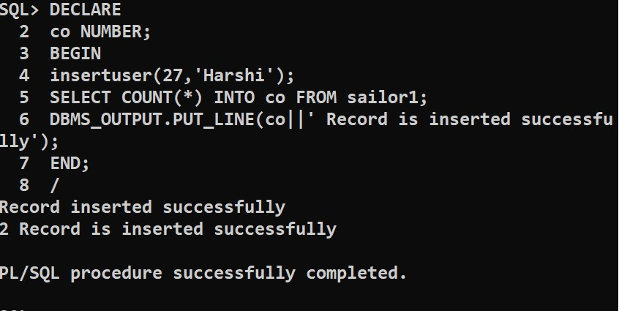DROP PROCEDURE:**

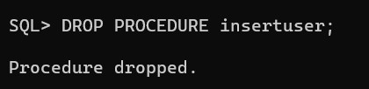

CONCLUSION : The PL/SQL program to implement Stored Procedure on table is successfully executed.